

**System Overview**

**Diploma name: Achievement Manager**

**Group: IT-2206 Zhayleubay Alibek**

Alikhan Sagatbekov

Dias Ibragimov

Advisor: Alshynov Shygys

Astana, 2023

**Contents**

1 Introduction ............................................................................................................................2

2 Team members…....................................................................................................................2

3 Literature Review.................................................................................................................3

4 User experience design of the system……………………………………………………….8

4 APPLICATION…………………………………………………………………………….11

5 Conclusion………………………………………………………………………………….21

**Introduction**

Our project is aimed at developing a Web and mobile application that helps achieve certain goals. Training in the professional field, everyday life, etc.

A modern person has access to a huge number of Internet resources for consuming information. Many studies show that a person of the 21st century has a lot of responsibilities compared to the past. We have very little time for self-development or completing tasks. There are many cases when we start a new project / task / training, but for some reason we quit.

The task of our team was to make people's lives easier. In our diploma work, we studied the reasons for the early termination of work on projects, tasks and goals. We conducted surveys and studied existing scientific works. We came to the conclusion that many problems arise due to the lack of motivation, good convenient curators, a properly built system. We decided to create an application that solves many of these problems. During development, the following were used: Go Lang, Rekact, Tailwind, Mongodb, Openai.

Our main positive aspects of the application: Ability to complete tasks/goals together with friends. AI-based curator. Ability to split one large task into several mini tasks. And also to see real examples of other users. Ability to repeat their path.

As a result of our work, we created an application that allows users to develop together with friends, supervised by an AI curator. With the ability to repeat the path taken, other successful examples

**Team Members**

Zhaileuabay Alibek is responsible for Frontend application.

Alikhan Sagatbekov is responsible for the Frontend application.

Dias Ibragimov is responsible for the Backend application

**Literature Review**

In the course of studying the literature for a complete understanding of the course of learning on the Internet. Quality of information consumption global social and financial constraints. Motivation during work, the influence of group work, the influence of grades on the quality of work, a lot of work was done.

Intensive integration of digital technologies into the educational system is a trend throughout the world. Particular growth was noticed during the quarantine period of 2020. Most educational institutions switched to an online format of education

During the study, we received a number of important data. from 2015 to 2021, the number of online courses increased by 73%. In the Russian Federation by 2023, 75% of schools have implemented extensive digitalization in the course of education.

However, online education has its own problems.

So the main problems in the course of online education were identified. 34% or 39% lack of digital literacy. 27% or 29% due to lack of technical resources, depending on the sources. It was also found that a huge percentage of students who started online education often do not complete the courses. It was noted by teachers that, due to online learning, the quality of information consumption suffers greatly. First of all, the reason is considered to be the weak level of student motivation. The absence of a teacher willing to teach, to whom you can ask questions, etc. And also the lack of opportunity to achieve goals in groups of students

**User experience design of the system**

During the work on the client side, our main tool had to create the most convenient, understandable, urban and calm interface. During the work, many discussions were held on the subject of design. To simplify the work, Figma was initially created. So that we had an idea of ​​how our project should look.

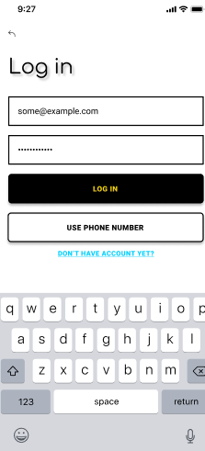 Изображение выглядит как текст, снимок экрана, число, Шрифт

Контент, сгенерированный ИИ, может содержать ошибки. Изображение выглядит как текст, снимок экрана, число, Шрифт

Контент, сгенерированный ИИ, может содержать ошибки.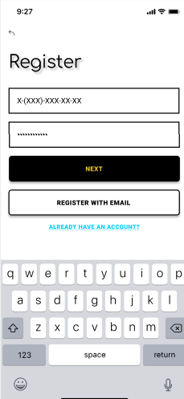

*Figure 7. /login/registration*

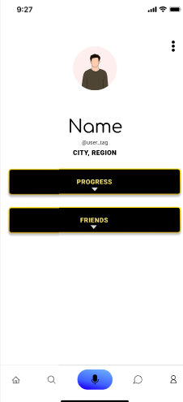 Изображение выглядит как текст, снимок экрана, дизайн

Контент, сгенерированный ИИ, может содержать ошибки. 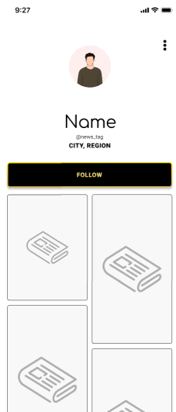

*Figure 8. Profile page*

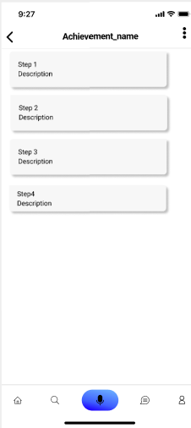 Изображение выглядит как текст, снимок экрана, чек

Контент, сгенерированный ИИ, может содержать ошибки.

*Figure 9. Achievement pages*

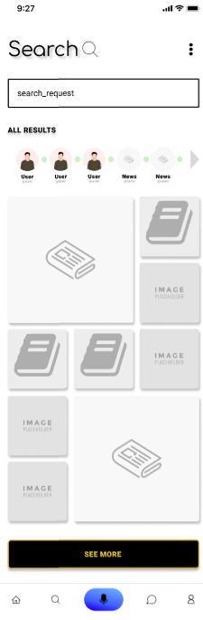 *Изображение выглядит как текст, снимок экрана, чек

Контент, сгенерированный ИИ, может содержать ошибки.*

*Figure 10. Seach of templates*

**APPLICATION**

Our application provides users with the opportunity to receive price forecasts for the bitcoin cryptocurrency. Users can register in the application using the registration system via SMS using Firebase. After successful registration, the user will be asked to provide their details, such as profile picture, name, email address and city. In addition, the user must accept the terms of use of the application.

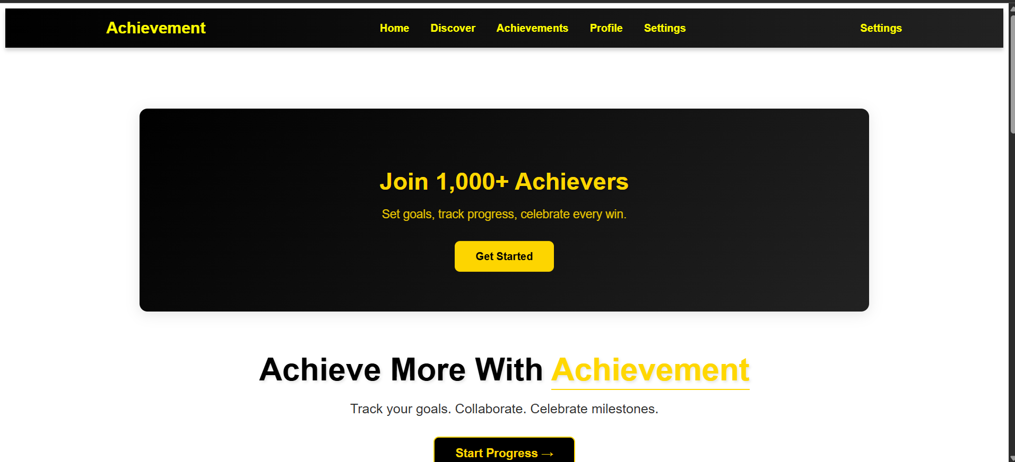

Изображение выглядит как текст, снимок экрана, программное обеспечение, Мультимедийное программное обеспечение

Контент, сгенерированный ИИ, может содержать ошибки.

Изображение выглядит как текст, снимок экрана, программное обеспечение, Мультимедийное программное обеспечение

Контент, сгенерированный ИИ, может содержать ошибки.

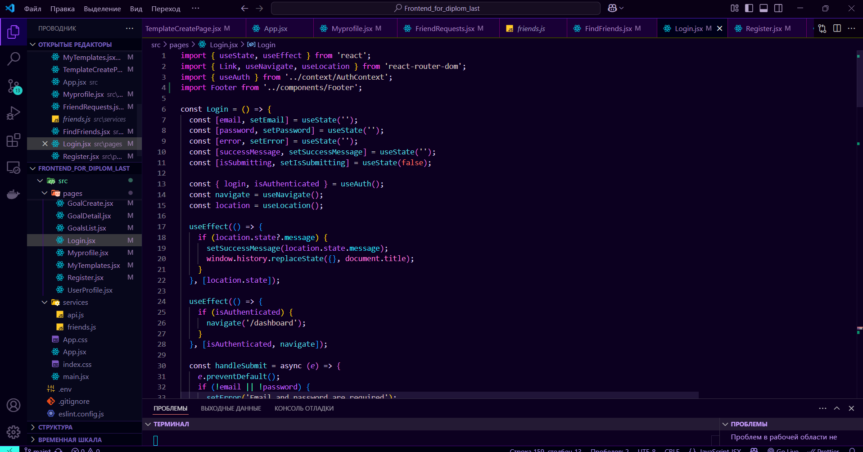

Изображение выглядит как текст, снимок экрана, программное обеспечение

Контент, сгенерированный ИИ, может содержать ошибки.

Изображение выглядит как снимок экрана, текст, программное обеспечение, Мультимедийное программное обеспечение

Контент, сгенерированный ИИ, может содержать ошибки.

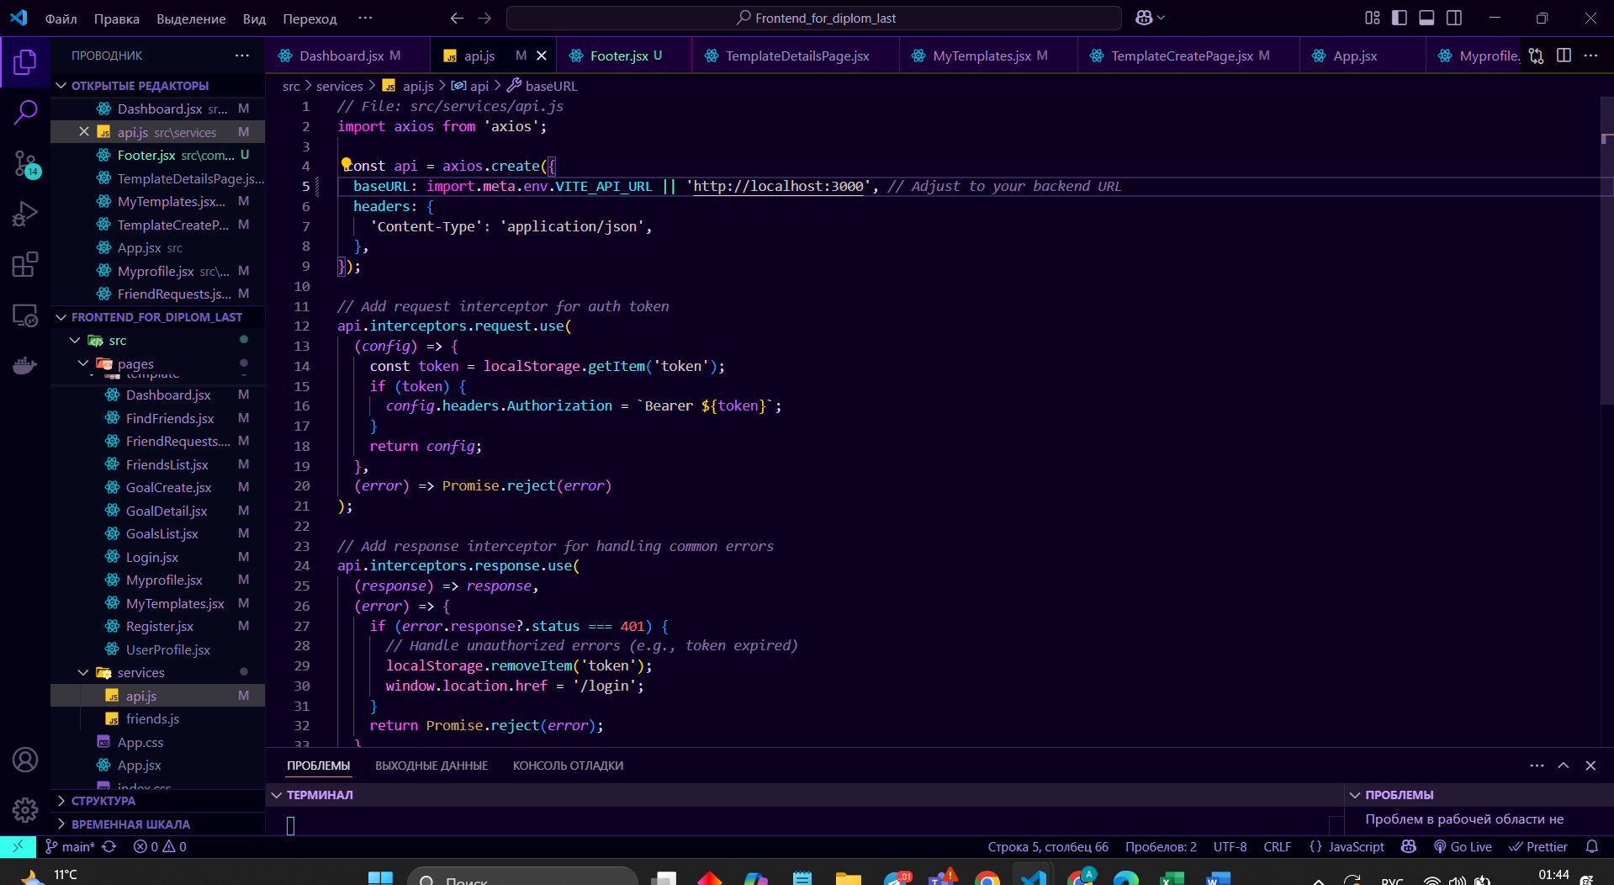

After the main page, the user will have the opportunity to register or log into an account after the additional page. An unauthenticated user will only be able to view the home page without any functionality. At the end you can see auth system api.

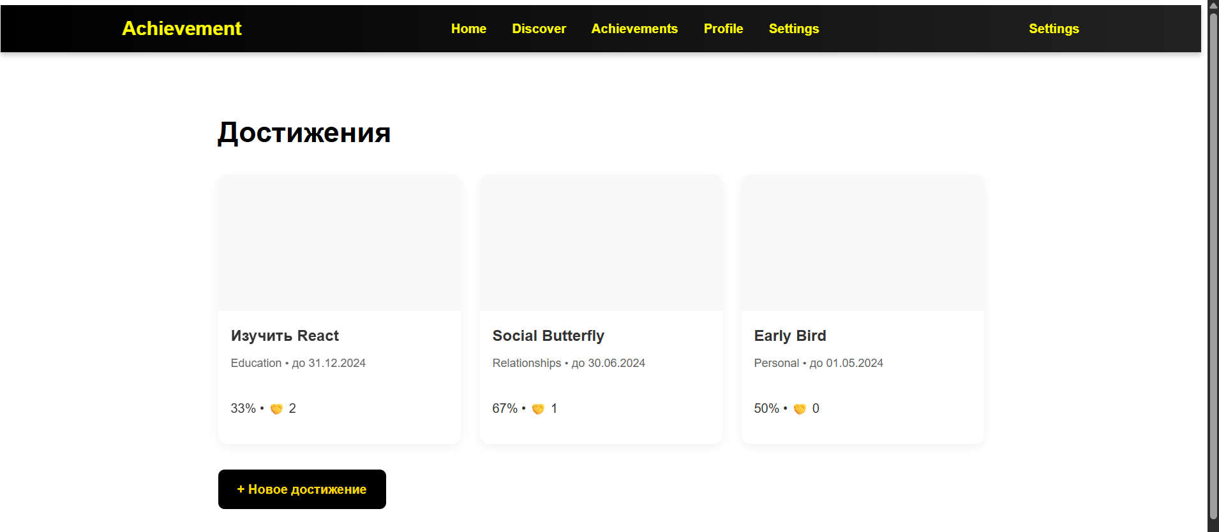

Изображение выглядит как снимок экрана, текст, программное обеспечение, Мультимедийное программное обеспечение

Контент, сгенерированный ИИ, может содержать ошибки.

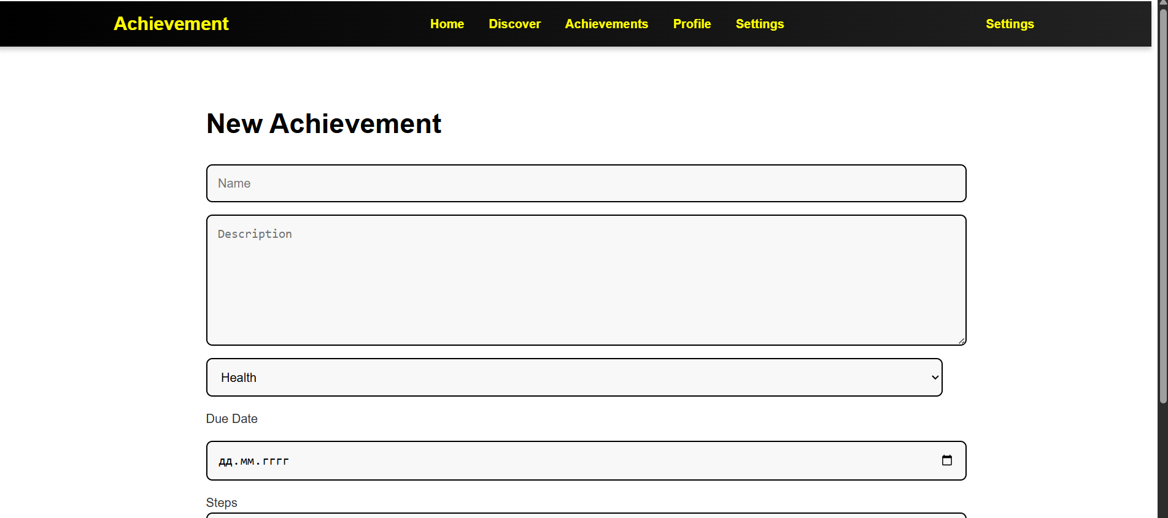

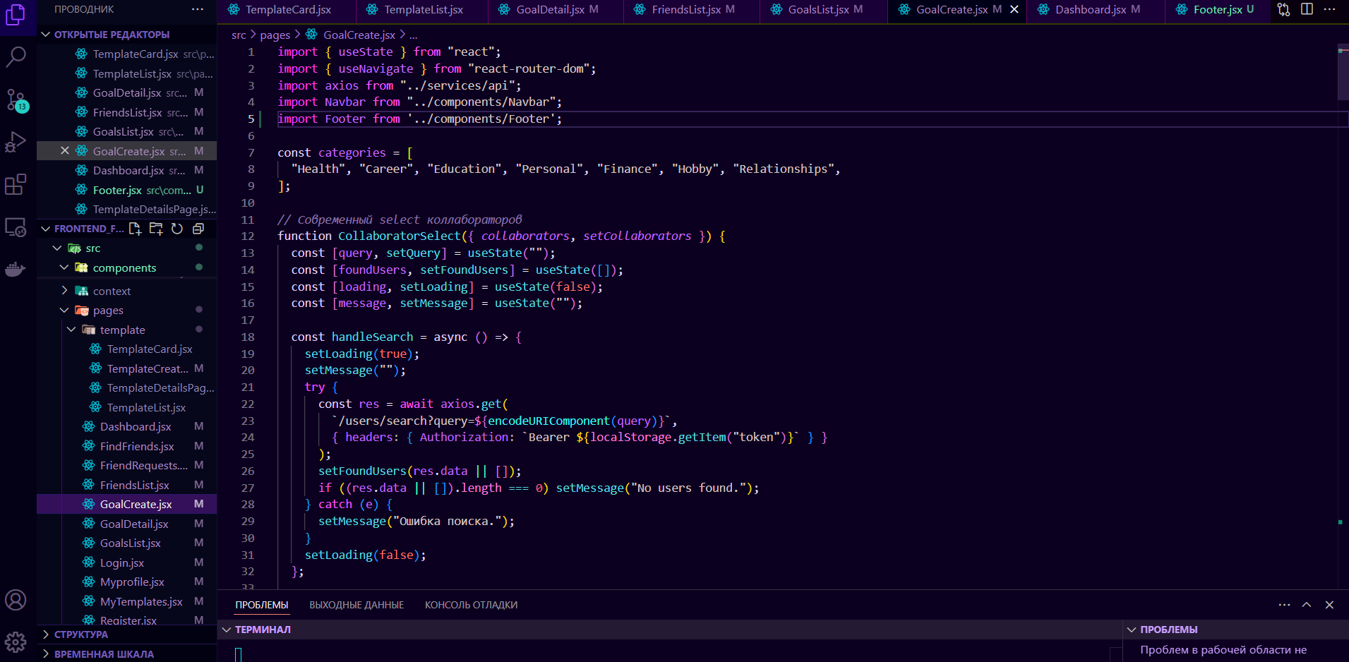

Изображение выглядит как текст, снимок экрана, число, программное обеспечение

Контент, сгенерированный ИИ, может содержать ошибки.

Изображение выглядит как снимок экрана, текст, программное обеспечение, Мультимедийное программное обеспечение

Контент, сгенерированный ИИ, может содержать ошибки.

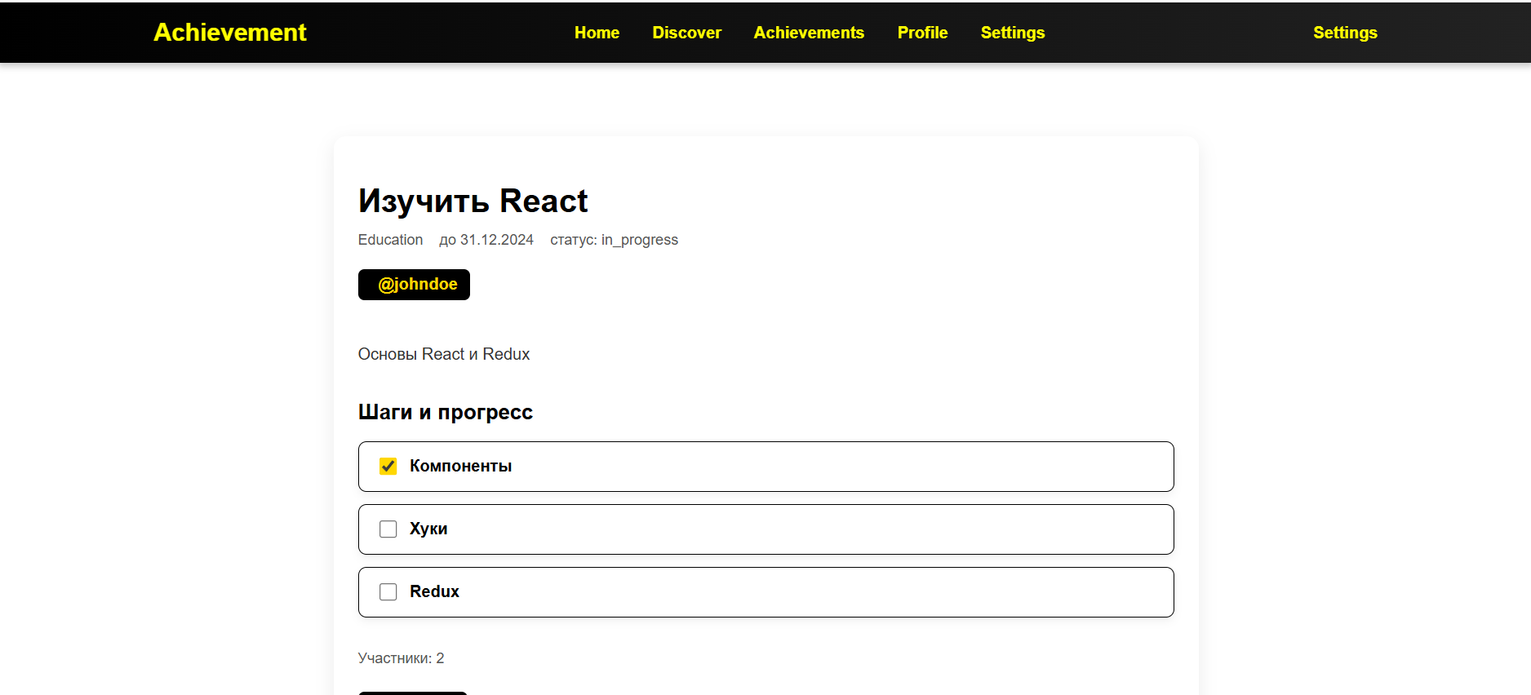

Изображение выглядит как снимок экрана, текст, программное обеспечение, Мультимедийное программное обеспечение

Контент, сгенерированный ИИ, может содержать ошибки.

The logic of the checkpoint is one of the most basic of our project, the user can create a new checkpoint, add steps there, edit it, add collaborators (friends) The ability to complete goals, mark checklists, etc. Each detail is accompanied by animation. There are deadlines for each project.Изображение выглядит как текст, снимок экрана, программное обеспечение, Мультимедийное программное обеспечение

Контент, сгенерированный ИИ, может содержать ошибки.

Изображение выглядит как текст, снимок экрана, программное обеспечение, Мультимедийное программное обеспечение

Контент, сгенерированный ИИ, может содержать ошибки.

Изображение выглядит как текст, программное обеспечение, Мультимедийное программное обеспечение, Значок на компьютере

Контент, сгенерированный ИИ, может содержать ошибки.

Изображение выглядит как текст, снимок экрана, программное обеспечение, Мультимедийное программное обеспечение

Контент, сгенерированный ИИ, может содержать ошибки.

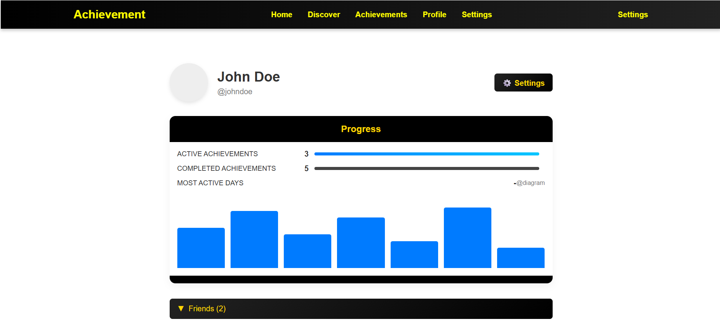

Изображение выглядит как текст, снимок экрана, программное обеспечение, Мультимедийное программное обеспечение

Контент, сгенерированный ИИ, может содержать ошибки.

The user page contains basic information about him, his referred friends, how many and what goals he used. Preview of the data and a detailed description. Such data can only be viewed by the user himself or his friend. Each detail is accompanied by animation

Изображение выглядит как электроника, текст, снимок экрана, дисплей

Контент, сгенерированный ИИ, может содержать ошибки.

The logic of viewing the profile of other users, only friends, is also prescribed. The profile of a user who is not a friend is only available to the admin

Изображение выглядит как снимок экрана, программное обеспечение, текст, Мультимедийное программное обеспечение

Контент, сгенерированный ИИ, может содержать ошибки.

This file we use to control routs of user and protect it/

Изображение выглядит как снимок экрана, текст, программное обеспечение, Мультимедийное программное обеспечение

Контент, сгенерированный ИИ, может содержать ошибки.

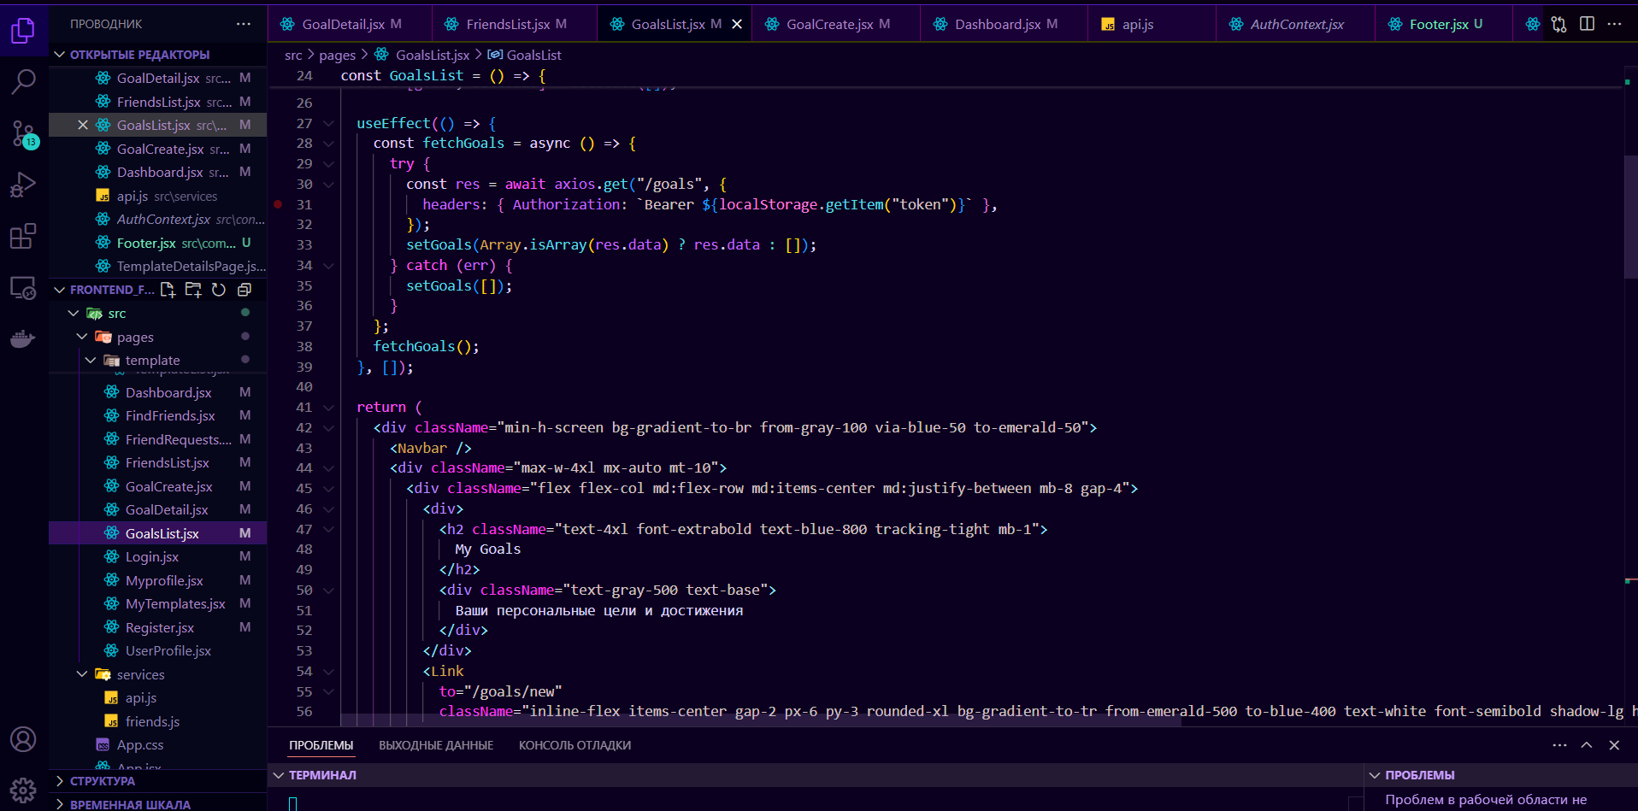

Here you can see AuthContext that work with JWT tokens to auth users. This file very important in work whith JWT. Not only in auth systems and in others. In Second picture you can see the realization of it.

Изображение выглядит как текст, снимок экрана, программное обеспечение, Мультимедийное программное обеспечение

Контент, сгенерированный ИИ, может содержать ошибки.

Изображение выглядит как текст, снимок экрана, программное обеспечение, Мультимедийное программное обеспечение

Контент, сгенерированный ИИ, может содержать ошибки.

Here you can see the commits in git. Every important achievement was pushed to the repository. There is also a collaborator Sagatbekov Alikhan, with his branch and his pushes.

**Conclusion**

In conclusion, our project focused on creating a mobile app that helps users predict cryptocurrency price changes, with a specific focus on Bitcoin. We aimed to provide a comprehensive and user-friendly experience that enables users to make informed decisions in the cryptocurrency market. Throughout the development process, we utilized data analysis and machine learning techniques to train prediction models. By analyzing historical price data from Binance, we were able to compare different models and select the most accurate one for integration into our app. The registration process in the app was designed to be smooth and secure. Users could easily sign up by verifying their identity through SMS. Once registered, they were prompted to provide basic information such as their profile photo, name, email, and city. Accepting the app's terms and conditions was also required. Upon successful registration, users gained access to the main page of the app. This page presented key information about cryptocurrencies, including a list of top cryptocurrencies and two categories: "Best Performers" and "Worst Performers." This feature allowed users to quickly get a sense of the current market trends. The app's second page provided a comprehensive list of all available cryptocurrencies. Users could explore detailed information about each cryptocurrency, including the current price. Additionally, they could view price charts over specific time intervals, enabling them to track and analyze price trends more effectively. To personalize their experience, users could add cryptocurrencies to their watchlist or favorites. This feature allowed them to easily keep track of the cryptocurrencies they were most interested in. Moreover, users had the option to set up notifications, ensuring they received timely updates on important cryptocurrency developments, such as significant price movements or market shifts.

Overall, our app aimed to empower users with accurate predictions and valuable insights to make informed investment decisions in the cryptocurrency market. By combining advanced technologies, intuitive design, and real-time data, we created a valuable tool that can assist users in navigating the ever-changing world of cryptocurrencies.

Through this project, we showcased the potential of technology in analyzing cryptocurrency data, predicting price changes, and providing users with relevant information. We strongly believe that our app can help users optimize their investment strategies and stay well-informed about the latest trends in the cryptocurrency market.